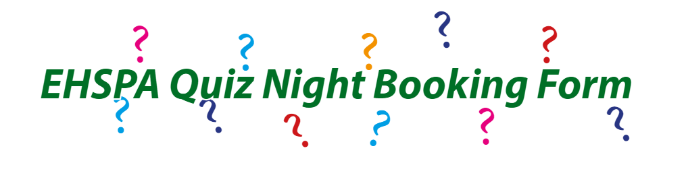Friday 16th May 2025

7pm for a 7.30pm start in the Senior Hall

Name:  
Email:  
No. Of tickets:  
No. of Chicken meals: Rice / Noodles   
No. Of Vegetable meals: Rice / Noodles  
No. Of Gluten Free meals:

Daughter’s Name: Form:  
Are you in a team? Yes / No  
Yes, my team's name is :  
No, please allocate me/us to a team:  
**Payment can be made via cash (to be enclosed with this form and handed in to prep or senior reception) or card and payments can be made at prep reception with the filled in form. You will receive an email confirmation of your booking.**  
I wish to purchase ___ tickets and that the sum of £____ (£10 per ticket) has been paid by cash and is enclosed with this form.  
Signed : Date:  
If paying by bank transfer, please complete the form and send via email to [ehspaevents@edgbastonhigh.co.uk](mailto:ehspaevents@edgbastonhigh.co.uk)

And please pay  
EHS Parents Association  
Account number: 30910562  
Sort Code: 20-08-44  
  
Do not forget to quote quiz and your daughter's surname and form as the reference. Please note that no refunds can be provided. If you are purchasing tickets on behalf of others you will be responsible for collecting any monies owed.